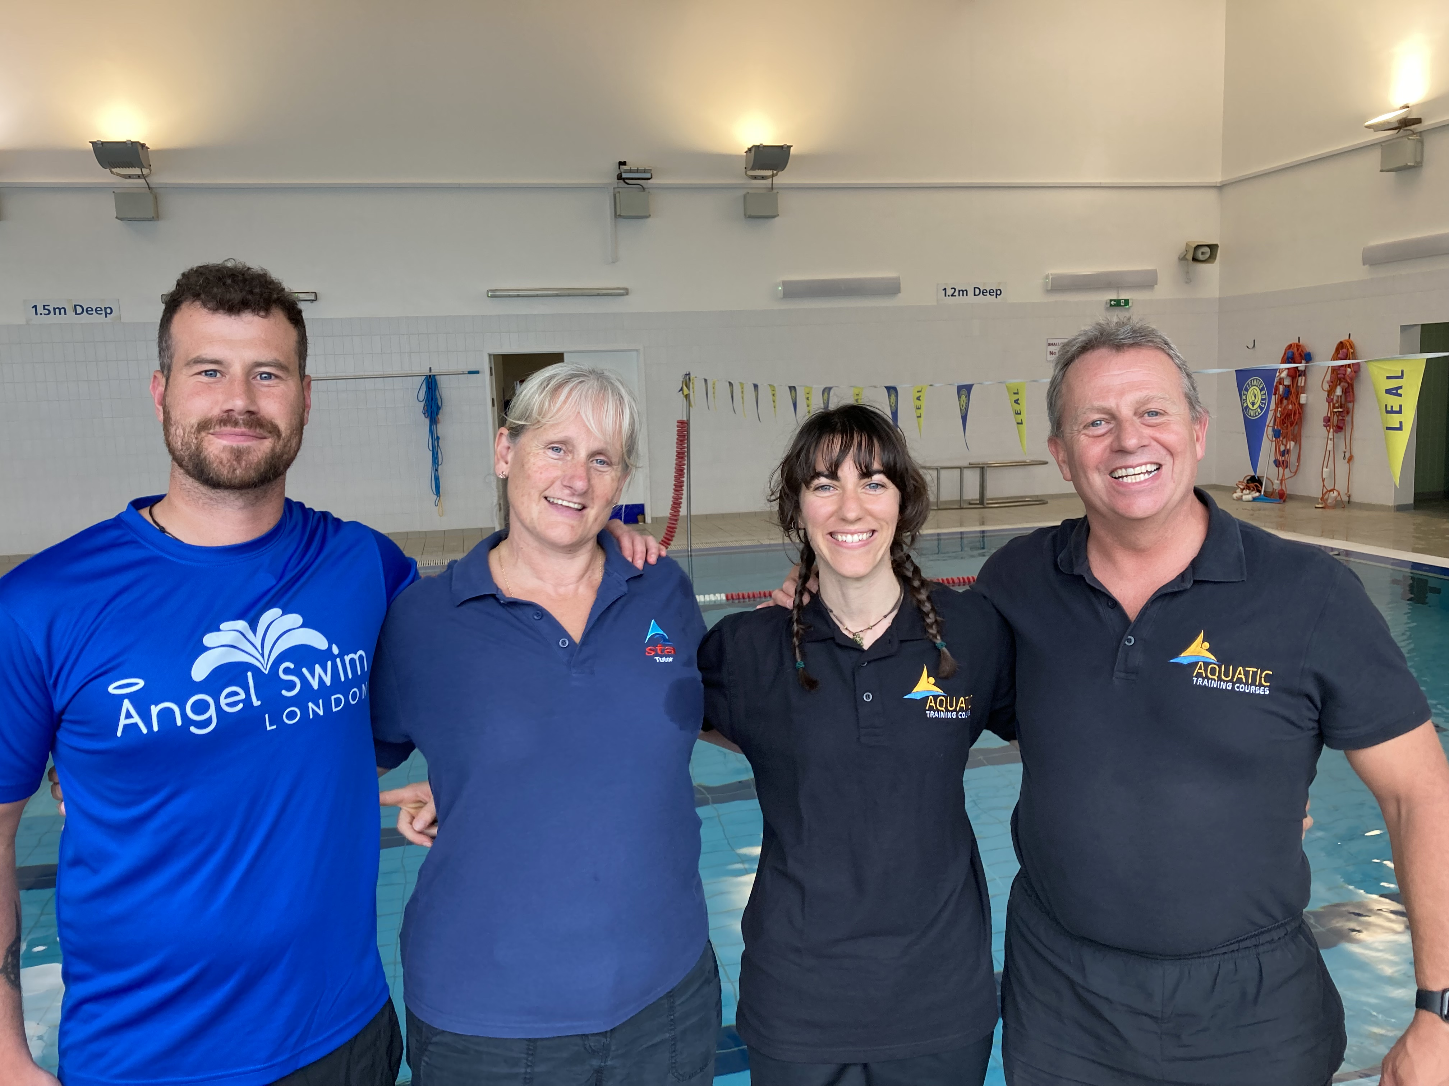 |  | Conflict of Interest Policy
 | ATC Name |  | AQUATIC TRAINING COURSES
 | ATC Address |  | 76 LUCIEN RD, LONDON SW17 8HN
 | Co-ordinator Name |  | DAVE PERRY
 | Contact Telephone |  | 07752 268 846
 | Contact Email |  | daveperry@aquatictrainingcourses.com
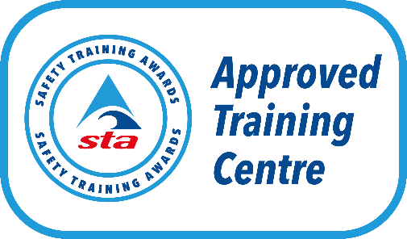
Monitoring and Review
This policy will be reviewed annually to ensure they remain correct and are fit for purpose. However, the policy may be reviewed and updated at any time to reflect any changes made by Safety Training Awards (STA) or the Regulatory authorities.
Version: | 3
Policy Launch Date | 26.10.25
Next Review Date | 26.10.26

Purpose
All staff, delivery staff, assessors, IQAs, EQAs, volunteers and management members of the named Approved Training Centre (ATC) will strive to avoid any conflict of interest between the interests of the Organisation on the one hand, and personal, professional, and business interests on the other. This includes avoiding actual conflicts of interest as well as the perception of conflicts of interest.
The purpose of this policy is to protect the integrity of the Organisation's decision-making process, to enable our learners to have confidence in our integrity, and to protect the integrity and reputation of volunteers, staff, awards and awarding organisation.
The main conflicts of interest may include as follows:
- Tutors who may manage the booking of assessments, registration of learners and printing of assessment materials for subjects they teach.
- Tutors acting as assessors for their own learners.
- Safety Training Awards staff acting as tutors or invigilators for an ATC.
- Tutors acting as Internal Quality Assurers (IQA) for their own learners.
- Tutors directly related to Internal Quality Assurers (IQAs).
This list is not exhaustive

Document review
Our policy is reviewed on an annual basis

Document audience
Due to the potentially confidential information in ATC documents and information this policy is for internal staff and those working by request.
It will be made available to the awarding body and regulators on request.
This policy covers the identifications and mitigation of conflicts of interest that may lead the named ATC in experiencing an adverse effect.
This policy outlines the roles and responsibilities of individuals within the organisation in relation to identifying and declaring conflicts of interest.
This policy applies to all staff including but not limited to:
- All staff
- All volunteers
- IQAs
- EQAs
- External examiners / assessors
- family of staff and volunteers

Definition of a Conflict of Interest
Ofqual defines that a conflict of interest exists in relation to an awarding organisation where:
(a) Its interests in any activity undertaken by it, on its behalf, or by a member of its Group have the potential to lead it to act contrary to its interests in the development, delivery and award of qualifications in accordance with its Conditions of Recognition,
(b) A person who is connected to the development, delivery and award of qualifications by the Awarding Organisation has interests in any other activity which have the potential to lead that person to act contrary to his or her interests in that development, delivery or award in accordance with the awarding organisation’s Conditions of Recognition, or
(c) Any informed and reasonable observer would conclude that either of these situations was the case.
Where a learner identifies a potential conflict of interest that requires an immediate resolution, they should verbally declare this conflict to the most senior member of the ATC team who will manage this in accordance with the procedure.
All verbal declarations are still required to be reported to the ATC Co-ordinator / Centre Manager.

Intelligence
Potential conflicts of interest may be identified through a range of intelligence channels. These may include, but are not limited to:
- EQA reports
- Social media
- Forums and working parties
- Training Centre support interactions
- Regulatory guidance and notifications
Staff members and others identifying potential conflicts through these channels should report them to the ATC Co-ordinator / Centre Manager. The ATC Co-ordinator / Centre Manager is responsible for reviewing all submitted declarations and deciding whether there is a conflict of interest or not.
The ATC Co-ordinator / Centre Manager decision and rationale should be recorded on a declaration form. Whether a conflict of interest has been proven to exist or not, a record is made on the conflicts of interest register.
The ATC Co-ordinator / Centre Manager is responsible for updating and monitoring the conflicts of interest register which includes:
- Date declaration submitted
- Name of individual or group making the declaration
- Date reviewed by ATC Co-ordinator / Centre Manager
- Foreseeable impact
- Current controls in place
- Additional controls required
- Monitored by
- Open/closed

Managing conflicts of interest
It Is inevitable that conflicts of interest will arise, especially in a small company. The issue is not the integrity of the person(s) concerned but the effective management of such conflicts and any possible compromise to the ATC.
The purpose of managing the conflict is primarily to avoid the risk of an Adverse Effect as this can affect our business and our Conditions of Recognition. As an ATC, it may affect our registration. Managing conflicts of interest ensures that the ATC is responsible and transparent in its operations.

Data protection and confidentiality
The ATC named at the start of this policy will ensure all information provided to it will be held in accordance with the General Data Protection Regulations. Information shared will only be used to ensure all those involved with the awarding organisation act in the best interest of the organisation. Information will not be used for any other purpose.

I have read and understood the Conflict of Interest Policy in conjunction with the agreements set out by the named ATC and agree to the terms contained therein.
Name: | Dave Perry
Date: | 26.10.25

