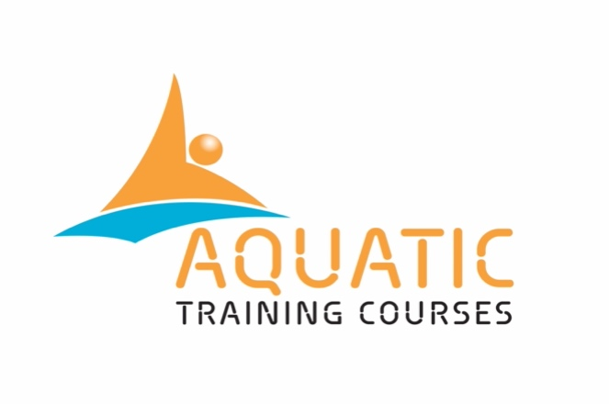 |  | Safeguarding Policy
 | ATC Name |  | AQUATIC TRAINING COURSES
 | ATC Address |  | 76 Lucien Rd, London SW17 8HN
 | Co-ordinator Name |  | DAVE PERRY
 | Contact Telephone |  | 07752 268 846
 | Contact Email |  | daveperry@aquatictrainingcourses.com
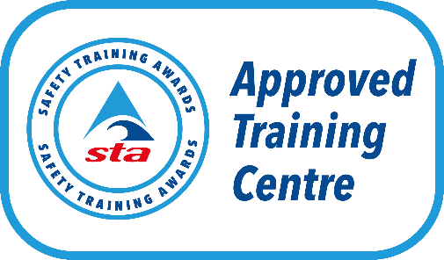
Monitoring and Review
This policy will be reviewed annually to ensure they remain correct and are fit for purpose. However, the policy may be reviewed and updated at any time to reflect any changes made by Safety Training Awards (STA) or the Regulatory authorities.
Version: | 7
Policy Launch Date | 26.10.2025
Next Review Date | 26.10.2026
Safety Training Awards recommends ATCs visit the websites listed in the Guidance for ATCs Creating Mandatory Policies and Procedures document for guidance on developing a suitable safeguarding policy for the ATC sites used to deliver and assess STA qualifications, or alternatively refer to the NSPCC website for more information - https://learning.nspcc.org.uk/.
Safety Training Awards recommends ATCs seek external advice to ensure you are compliant with current legislation.
Purpose
We have a responsibility to safeguard and promote the interest and well-being of children, young people under the age of 18 and vulnerable adults with whom it is working. Therefore this could include learners on a course or participants within practical sessions.
The purpose of this policy statement is:
- To protect children, young people, and vulnerable adults from harm. This includes the children of adults who use our services
- Take all reasonable steps to protect them from harm, discrimination, or degrading treatment
- To provide staff and volunteers, as well as children, young people and vulnerable adults and their families, with the overarching principles that guide our approach to child protection
- Identify the responsibilities for ATC staff regarding safeguarding
- Implement a clear and precise reporting procedure for safeguarding issues.
This policy applies to anyone working on behalf of the ATC named above, including senior managers and the board of trustees, paid staff, volunteers, sessional workers, agency staff and students.

Responsibilities for Safeguarding

The ATC Co-ordinator has the following responsibilities:
- Remain up to date with Safety Training Awards safeguarding policies, ATC policies and current legislation
- Take all reasonable steps during recruitment to ensure suitability of ATC staff
- Ensure ATC staff receive safeguarding training to help recognise abuse and promote best practice within the ATC
- Ensure ATC staff are up to date with the ATCs safeguarding policy and are aware of how to report suspected safeguarding issues
- Ensure learners and any other person encompassed within the ATC are aware of the ATCs safeguarding policy and are aware of how to report suspected safeguarding issues
- Take any reasonable action to prevent safeguarding issues by promoting best practice within the ATC
- Ensure the procedures within this policy are effective and updated accordingly
- Investigate any complaints surrounding safeguarding issues confidentially and impartially, seeking assistance from STAs Designated Safeguarding Officer (DSO) as necessary
- Monitor any complaints or safeguarding issues, including reasons and outcomes.
- Refer any safeguarding issues to the appropriate agencies and Safety Training Awards.

Tutor, Assessors, IQAs, have the following responsibilities:
- Remain up to date with Safety Training Awards safeguarding policies, ATC policies and current legislation
- Participate in any safeguarding training and ensure certification is updated in line with STA requirements and current legislation
- Keep up to date with the ATC safeguarding policy and be aware of how to report suspected safeguarding issues
- Safeguard and promote the interests and well-being of children, young people and vulnerable adults through best practice and conduct
- Refer any safeguarding issues to the ATC Co-ordinator, Safety Training Awards, or the relevant authorities
- Inform the ATC Co-ordinator of any actual or suspected safeguarding issues
- Co-operate with any safeguarding investigations by the relevant agencies or authorities.

Policy

Prevention
The ATC named above recognise the importance of ensuring reasonable steps are taken to prevent unsuitable people working with children, young people and vulnerable adults. When undertaking recruitment checks the following evidence is collated and checked to establish the suitability of the person:
- Tutors, Assessors, IQAs are asked to provide evidence that they have a DBS check, if they have any criminal convictions and a copy of their work history and two references from professionals who are not related to the applicant
- Enhanced DBS checks are required if assigning to deliver specific qualifications within the ATC. The staff member will be required to keep their DBS check up to date in line with current legislation and STA requirements
- Details of any other ATCs the applicant operates for
- ATC staff must have a current / in date safeguarding certificate in line with current legislation and STA requirements or be willing to complete this prior to becoming operational with the ATC named above.

Training
The ATC named above requires Tutors, Assessors, IQAs, to hold a recognised safeguarding certificate which is renewed in line with STA requirements and current legislation. The ATC Co-ordinator may offer additional training or standardisation meetings when deemed necessary and/or if any issues arise that may prompt the need for additional training.

Recognition of abuse
The ATC Co-ordinator acknowledges that the ATC staff are not experts at recognising abuse, therefore all ATC staff must undertake appropriate safeguarding training to help them identify indications of abuse, the forms of abuse and the effects of abuse. If any person encompassed within the ATC has any concerns, suspicions or allegations surrounding child abuse, the ATC named above expects them to report the issue immediately via the reporting procedure.

Supervision and good practice
To protect both themselves and the learners or participants for who they are overall responsible for, ATC staff are expected to promote the following good practices when working on behalf of the ATC named above:
- Avoid unobserved one to one situations whether that be the Tutor, Assessor, IQA with a learner or a student learner with a fellow peer or participants they are teaching as part of their training
- Where any form of manual support is required, this should be provided openly and with the assent of the child, young person or vulnerable adult and consent of the parent/guardian
- Where possible provide separate sex changing facilities and changing areas at different times to learners, placing the responsibility of changing the child, young person or vulnerable adult on the parents/guardians.
As good practice ATC staff should not partake or allow any of the following to take place:
- Rough, physical, or sexually provocative games, including horseplay
- Allow or engage in inappropriate touching of any form
- Allow children to use inappropriate language unchallenged
- Make sexually suggestive comments to a child even in a fun way
- Let allegations a child makes go unrecorded, or not acted upon
- Do things of a personal nature that children can do for themselves
- Have children stay at your home with you unsupervised
- Spend excessive amounts of time alone with children away from others
- Take still or movie photographs of children without obtaining the guardians consent in writing.

Reporting
The ATC named above and the ATC staff within the business have a responsibility to report any concerns so that the appropriate agencies and/or authorities can make inquiries and take any necessary action to protect the child, young person, or vulnerable adult. Whilst the ATC acknowledges the importance of the role of statutory agencies involved in children’s welfare (social services, police, NSPCC) and will work with such agencies for any investigations, the ATC named above will initially refer the suspected abuse to the STAs Designated Safeguarding Officer (DSO) at the earliest possible time after the event or allegation.

Recording
Any personnel encompassed within the ATC who needs to report a suspected case of abuse, they should make a record of any of the following points, if known:
- The nature of the allegation
- A description of any visible bruising or injuries
- The child’s account, if they can provide them, of what happened and how the bruises or injuries occurred
- Dates, times, or any other relevant information
- A clear distinction between what is fact, opinion, or hearsay.
The relevant site/venue manager should liaise with the ATC Co-ordinator to send the relevant information to the STAs Designated Safeguarding Officer (DSO) for further guidance and investigation.

Allegations of abuse against ATC staff
Any allegations surrounding safeguarding issues against ATC staff should be referred to the ATC Co-ordinator who will record the following information, if known:
- The nature of the allegation
- A description of any visible bruising or injuries
- The child’s account, if they can provide them, of what happened and how the bruises or injuries occurred
- Dates, times, or any other relevant information
- A clear distinction between what is fact, opinion, or hearsay.
The information will be sent to the STAs Designated Safeguarding Officer (DSO) at the earliest possible time after the event or allegation.
Whilst the ATC Co-ordinator awaits the outcome from the DSO and any other agencies or authorities, the person in question may face temporary sanctions to protect the interests of the learners and the ATC. A complaint via the ATC named above complaints policy may coincide with any safeguarding investigation.
If the allegation is against the ATC Co-ordinator the accuser may refer direct to STAs Designated Safeguarding Officer (DSO).

Supporting information
- STAs Safeguarding Children, Young People and Vulnerable Adults Policy https://www.sta.co.uk/policies/
- NSPCC – Keeping children safe https://www.nspcc.org.uk/keeping-children-safe/
- NSPCC – Working together to keeping children safe https://learning.nspcc.org.uk/news/2018/july/working-together-to-safeguard-children-guidance-updated

