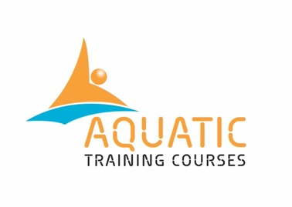 |  | Appeals Policy
 | ATC Name |  | AQUATIC TRAINING COURSES
 | ATC Address |  | 76 Lucien Rd
 | Co-ordinator Name |  | DAVE PERRY
 | Contact Telephone |  | 07752 268 846
 | Contact Email |  | daveperry@aquatictrainingcourses.com
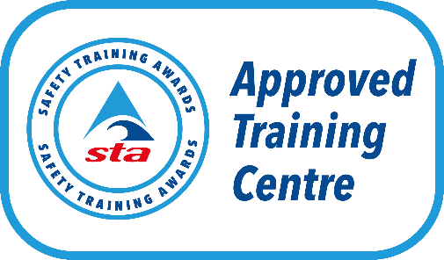
Monitoring and Review
This policy will be reviewed annually to ensure they remain correct and are fit for purpose. However, the policy may be reviewed and updated at any time to reflect any changes made by Safety Training Awards (STA) or the Regulatory authorities.
Version: | 7
Policy Launch Date | 26.10.25
Next Review Date | 26.10.26

Purpose
We are committed to providing an efficient and high standard of service to all. It is our aim to ensure that all assessment outcomes are fair, consistent, and reliable based on the valid judgements of the assessor using the assessment strategy for the STA qualification on offer. However, occasions may arise where the learner may wish to question a decision.

Policy
We will ensure:
- Assessments are carried out by assessors who have the appropriate qualifications, knowledge, understanding, and skills, and the assessments are valid for the subject or qualification in question
- Assessment evidence is authentic, solely being produced by the learner in question
- Consistency of assessment decisions covering all assessors over time
- Appeals are heard by individuals that have the appropriate competence to make decisions in each individual case and have had no prior involvement, or a personal interest in the case.
Everyone has the right to appeal if they believe that their assessment decision, or a decision following a malpractice or maladministration investigation is incorrect. This policy will define the stages and procedures you would need to follow, guidance is as follows:
- The process you need to follow to submit an enquiry or appeal
- The timescales for an enquiry or appeal
- How and when you will be notified of the outcome.
We will accept an appeal in relation to the following:
- Appeals against results of a course assessment and/or internal quality assurance monitoring activities
- Appeals against a decision made relating to a reasonable adjustment or special considerations application
- Appeals against decisions relating to any action taken against a learner following an investigation into malpractice or maladministration.
Firstly, we advise all learners to discuss any concerns or enquiries relating to the result of the assessment with the assessor to resolve the issue. If you are not satisfied with the outcome then please contact the ATC Co-ordinator for further advice and guidance.

ATC Appeals Process
If a learner is unhappy about the assessment decision awarded to them, they must first go through the ATC named above appeals process prior to contacting Safety Training Awards (STA).
Where possible, the ATC Co-ordinator will carry out an initial, informal assessment of the appeal, to ensure the application is complete and to ascertain if the issue can be resolved before it goes to a formal appeal. We may do so over the telephone or via email. In all cases we will ensure that the person carrying out this initial check does not have a personal interest in the decision being appealed. All actions will be confirmed via email.
On occasions a more formal approach is required and in these cases your appeal must be put in writing via email directly to the ATC Co-ordinator. If the appeal cannot be put in writing, a member of our team will relay any verbal communications via email, to ensure all details have been understood.

How to Submit an Appeal
Appeals should be made in writing via email to the ATC Co-ordinator within 10 working days of the assessment date. Please find the ATC and ATC Co-ordinator contact details at the end of this policy.
The appeal email must include the following information:
- Learner’s name and contact details
- Venue / site name
- Tutors name
- Assessors name
- Names of others involved
- Details of the reasons to appeal
- Copies of any supporting evidence.
If the appeal is excessively long or complex, we may ask you to provide a summary so that we are clear what the issues are.
All appeals will be acknowledged within 5 working days, investigated, and a response provided within 14 working days. If the process is likely to take longer, we will contact all involved to inform them of the revised timescale.
We will endeavour to complete any appeals within 14 working days of receipt of the initial appeal. To ensure a fair and thorough investigation, the duration may depend on the nature and severity of the appeal received, and the investigating team member will notify the appellant as soon as possible, if the investigation will take longer than expected.
If your appeal is not upheld, we will explain the reasons why via telephone and email.

Procedure to Escalate Appeals to Safety Training Awards (STA)
A learner may escalate an enquiry or appeal after they have exhausted the ATCs enquiries and appeal process and remain dissatisfied with the outcome. Any enquires and appeals must be submitted to Safety Training Awards (STA) within 28 days of course results being issued to the learner. Please refer to the Safety Training Awards enquiries and appeals policy on the website for further information https://www.safetytrainingawards.co.uk/.

Regulatory Escalation Procedures

Ofqual (England) and Qualifications Wales (QW) Escalation Procedures
If a customer or learner is not satisfied with the outcome decision from an ATC and Safety Training Awards Enquiries and Appeals procedures, they may escalate an appeal to the relevant regulator.
Please note the regulators are unable to overturn an assessment decision for regulated qualifications that are offered by an Awarding Organisation (AO).
Ofqual
Earlsdon Park, 53-55 Butts Road
Coventry, CV1 3BH
Tel: 0300 303 3344 / Email: public.enquiries@ofqual.gov.uk
https://assets.publishing.service.gov.uk/government/uploads/system/uploads/attachment_data/file/1058907/6905_-_Ofqual_complaints_procedure.pdf
Qualifications Wales
Q2 Building, Pencarn Lane,
Imperial Park, Coedkernew
Newport, NP10 8AR
Tel: 01633 373 222 / Email: enquiries@qualificationswales.org

SQA Accreditation (Scotland) Escalation Procedures
If a customer or learner is not satisfied with the final response from the ATC they may submit their enquiry or appeal to Safety Training Awards by referring to the relevant policy on the website and following the correct procedures.
If a customer or learner is not satisfied with the outcome of the appeal to Safety Training Awards they may refer the complaint to SQA Accreditation (Scotland). If the complaint relates to delivery by a school or public leisure centre, or any other public body in Scotland, the complaint may also be referred to the Scottish Public Service Ombudsman. Please see below for the relevant contact details:
SQA Accreditation (Scotland)
SQA Accreditation, The Optima Building, 58 Robertson Street, Glasgow, G2 8DQ
Tel: 0345 213 5249
Website: accreditation.sqa.org.uk
Email: accreditation@sqa.org.uk
For complaints relating to schools or public leisure centres in Scotland a complaint can be raised with the Scottish Public services Ombudsman as follows:
SPSO
Freephone adviceline: 0800 377 7330
Fax: 0800 377 7331
Website: https://www.spso.org.uk/how-to-complain-about-public-service
Online contact form: www.spso.org.uk/contact-form
You can fill in our complaints form online at www.spso.org.uk/complain/form
In Person: SPSO, Bridgeside House, 99 McDonald Road, Edinburgh, EH7 4NS
By Post: Freepost SPSO

